**Acceptance Test Cases**

**Test Case 001: Start New Game**

|  |  |
| --- | --- |
| **Test Case ID** | TC001 |
| **Test Case Summary** | The user opens the application and creates a new game with user defined variables. |
| **Related Test Cases** | Change Difficulty (TC002) |
| **Pre-Conditions** | * N/A |
| **Test Procedure** | 1. User selects the puzzle difficulty from 1-10. 2. User selects level from 1-10. 3. User presses ‘Submit’. |
| **Post-Conditions** | 1. The SudokuMaster game is playable. 2. Game starts with the user requested level and user requested difficulty |
| **Extensions** | * Adding an option to start a game with a random difficulty and level |
| **Exceptions** | * No level.php found. |

**Test Case002: Change Difficulty**

|  |  |
| --- | --- |
| **Test Case ID** | TC002 |
| **Test Case Summary** | User selects difficulty from a scale ranging 1 to 10 which determines amount of cells given at the start of the match. |
| **Related Test Cases** | Start new game (TC001) |
| **Pre-Conditions** | 1. Level must be selected. 2. level.php must be functional |
| **Test Procedure** | 1. User navigates to the ‘Difficulty’ list on the index.php page. 2. User will pick the hardest difficulty; Difficulty 10 |
| **Post-Conditions** | * A game with the selected difficulty(10) will start. |
| **Extensions** | * Add more difficulty levels (>10) |
| **Exceptions** | * Difficulty is less than 1 or greater than 10. |

**Test Case 003: Give Up**

|  |  |
| --- | --- |
| **Test Case ID** | TC003 |
| **Test Case Summary** | The user gives up on the current puzzle once the game has started. This ends the game and displays the solution in an alert box. The ‘submit’ button will also be disabled. |
| **Related Test Cases** | N/A |
| **Pre-Conditions** | 1. Game has to be initiated and in progress. |
| **Test Procedure** | 1. User presses the ‘Give Up’ button on level.php. 2. User will see the solution for the table in a Javascript alert. |
| **Post-Conditions** | 1. Submit button is disabled 2. User is prevented from submitting any more answers. |
| **Extensions** | * N/A |
| **Exceptions** | * No giveUp.js found. * No answer key found. |

**Test Case 004: Submit user table**

|  |  |
| --- | --- |
| **Test Case ID** | TC004 |
| **Test Case Summary** | User submits ‘complete’ sudoku puzzle to check for correct answers. If incorrect, game will display an error message. |
| **Related Test Cases** | Save/Store Game Score (TC005) |
| **Pre-Conditions** | 1. All squares must be filled in to submit. 2. User wants to submit their table. |
| **Test Procedure** | 1. User clicks on the ‘Submit’ button on level.php 2. Game will display an error message if the board is incorrect |
| **Post-Conditions** | 1. Game page will redirect to leaderboard page upon submit. |
| **Extensions** | * Submit user scores to a global leaderboard that is hosted on a serverside database. |
| **Exceptions** | * User does not have complete table. * User has invalid numbers (less than 1 or greater than 9) in cells. |

**Test Case 005: Save/Store Game Score**

|  |  |
| --- | --- |
| **Test Case ID** | TC005 |
| **Test Case Summary** | Starting a new game after opening application. |
| **Related Test Cases** | Submit user table (TC004) |
| **Pre-Conditions** | 1. User has completed level. 2. User wants to add name to leaderboard. |
| **Test Procedure** | 1. User submits initials by entering within the input box |
| **Post-Conditions** | 1. Name is posted on leaderboards if score is high enough. |
| **Extensions** | * Leaderboards can be sorted by region, different score brackets |
| **Exceptions** | * No leaderboard text files found. * No submit.php found. |

**ACCEPTANCE TEST CASE PHOTOS**

1. As shown below, level and difficulty set goes into a user defined level:

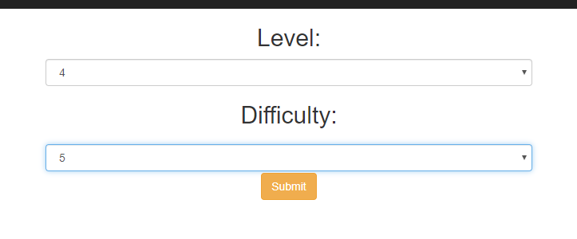

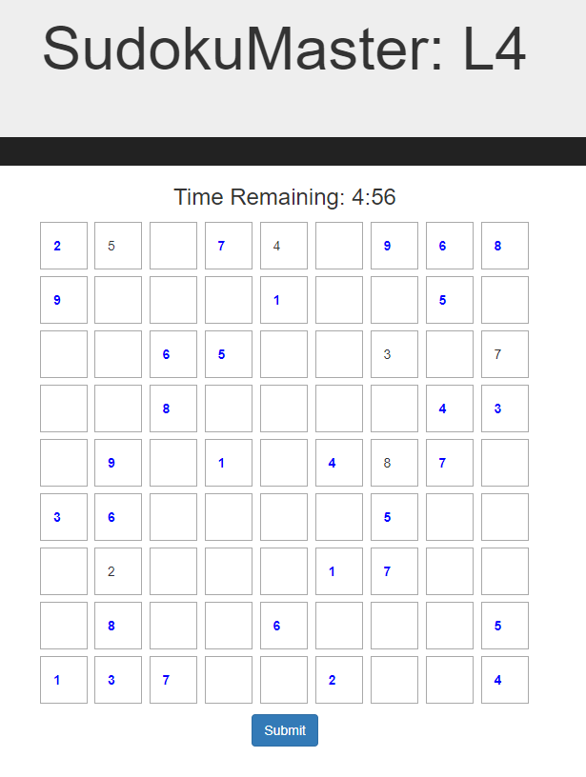

1. As shown below, setting difficulty:

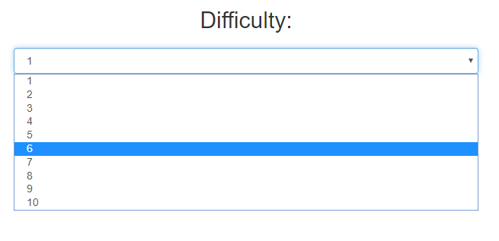

1. As shown below, giving up:

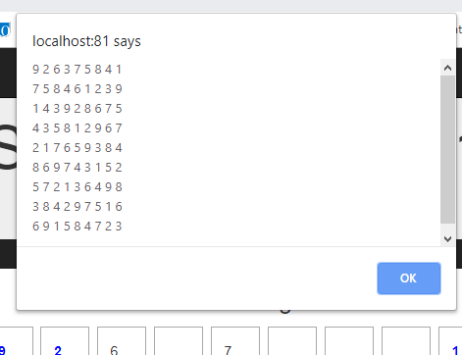



1. As shown below, submitting level:

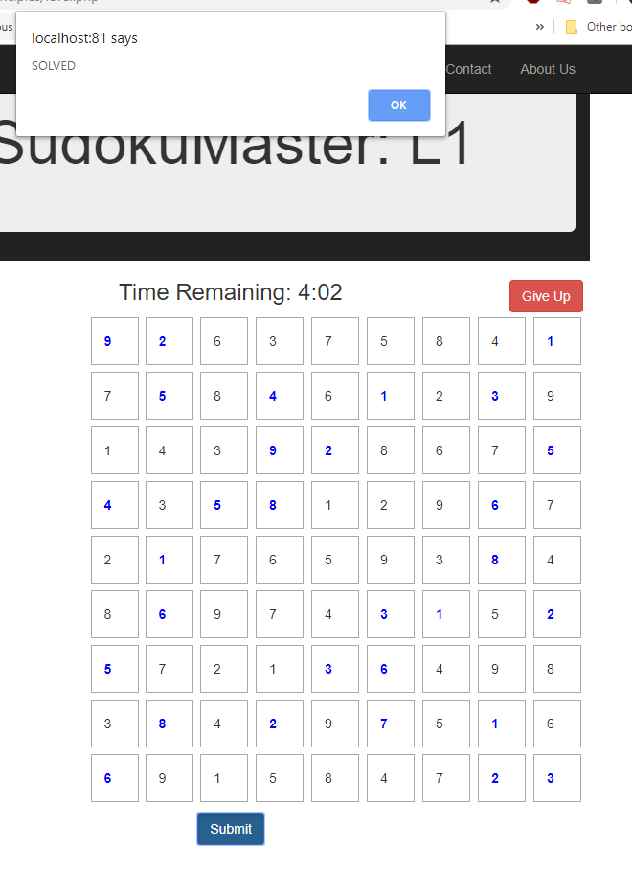

1. As shown below, sending score:

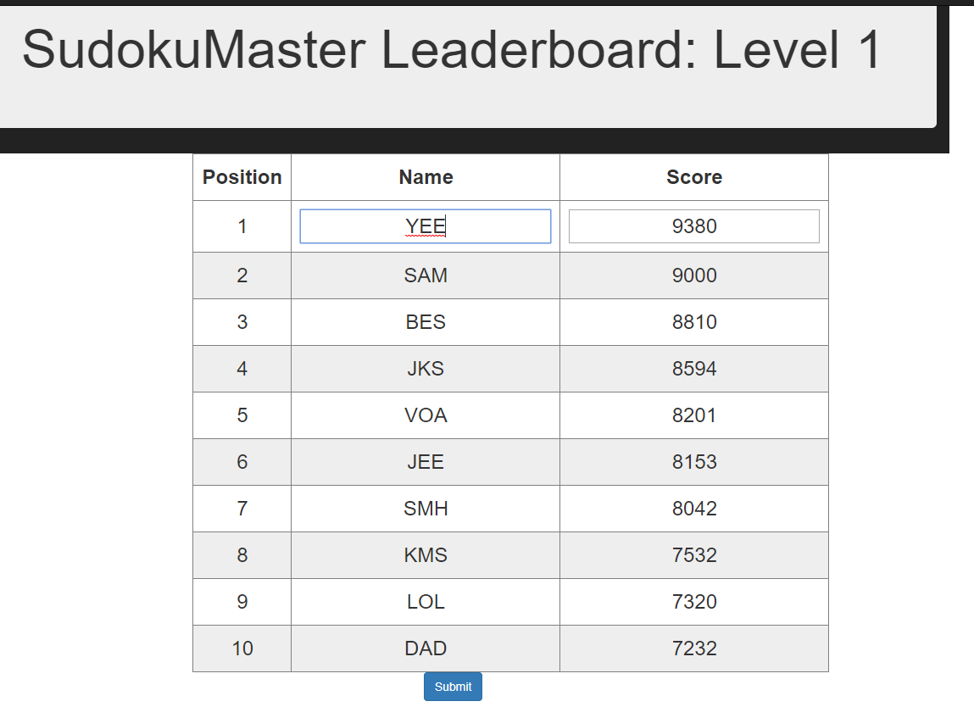

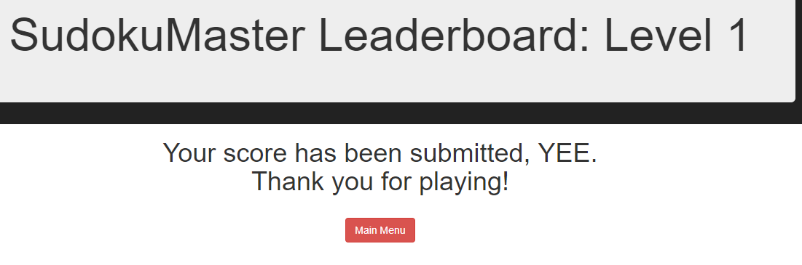

**INTEGRATION TEST**

The test method we have chosen is the “Big Bang” approach. We have four different web pages:

* Index.php
* Level.php
* Leaderboard.php
* Submit.php

All of these have been integrated at a single moment in time.  The following behaviour is expected of the program:

|  |  |  |  |  |
| --- | --- | --- | --- | --- |
|  | **State 1** | **State 2** | **State 3** | **State 4** |
| **Webpage** | index.php | level.php | leaderboard.php | submit.php |
| **What is being received** | - N/A | - level  - difficulty | - time remaining | - user initials  - user score |
| **What is being passed** | - level  - difficulty | - time remaining | - user initials  - user score | - N/A |
| **Pre-actions taken by system** | - N/A | - retrieve solution key of user specified level  - obfuscate random cells in table based on difficulty  - set time to 5:00 | - display leaderboard for level user has played  - calculate user score with user's time remaining | - N/A |
| **Actions taken by user** | - submit level and difficulty | - submit input | - submit initials | - N/A |
| **Post-actions taken by system** | - Return specified level with specified difficulty | - validate input  - redirect to leaderboard with user's time remaining | - pass initials and score to submission form | - update leaderboard of user specified level with user's initials and score in appropriate ranking.  - redirect user to index page |

The following output was received from a tester:

|  |  |  |  |  |
| --- | --- | --- | --- | --- |
|  | **State 1** | **State 2** | **State 3** | **State 4** |
| **Webpage** | index.php | level.php | leaderboard.php | submit.php |
| **What is being received** | - N/A | - 2  - 4 | - 3:18 | - DJS  - 8980 |
| **What is being passed** | - 2  - 4 | - 3:18 | - DJS  - 8980 | - N/A |
| **Pre-actions taken by system** | - N/A | - retrieve solution key of user specified level  - obfuscate random cells in table based on difficulty  - set time to 5:00 | - display leaderboard for level 2.  - calculate user score with user's time spent on question:  (10000 - (10)(102)) =  (10000 - 1020) =  8980 | - N/A |
| **Actions taken by user** | - user requests level 2 and difficulty 4.  - user submits. | - user submitted correct values in 1 minute, 42 seconds. | - user submits initials 'DJS'. | - N/A |
| **Post-actions taken by system** | - Return specified level with specified difficulty. | - validate input  - redirect to leaderboard with user's time remaining. | - pass initials 'DJS' and score '8980' to submission form. | - update leaderboard in file 'lboard2.txt with new values, placing 'DJS' + ‘8980’ in the appropriate ranking’  - user redirects to index page. |